3/19 trial shuffle and
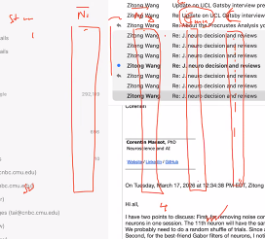
Geometric mean of means: product of two means
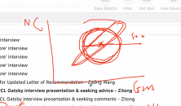
If non-correlated, take the average of the noise correlation

Variance and mean of noise correlation for each pair of neurons, you get a two-dimensional plot. Mean as x and variance as y. each point is one neuron pair.

All 50 stimuli or top 5-10 in terms of geometric means
